SCHOOL RULES
______________________________________________________________________________
______________________________________________________________________________
_____________________________________________________________________________
________________________________________________________________________________________________________________________________

________________________________________________________________________________________________________________________________

________________________________________________________________________________________________________________________________
SPORT RULES
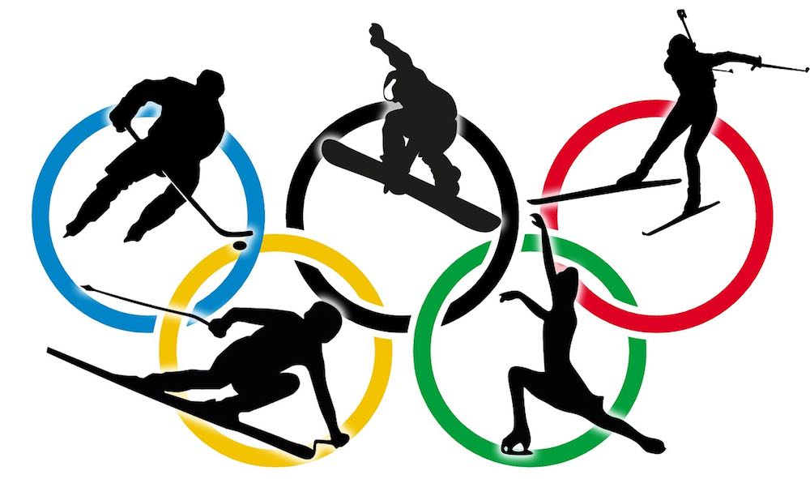
___________________________________________________________________
___________________________________________________________________
___________________________________________________________________

__________________________________________________________________________________________________________________________

__________________________________________________________________________________________________________________________

__________________________________________________________________________________________________________________________

TRAFFIC RULES
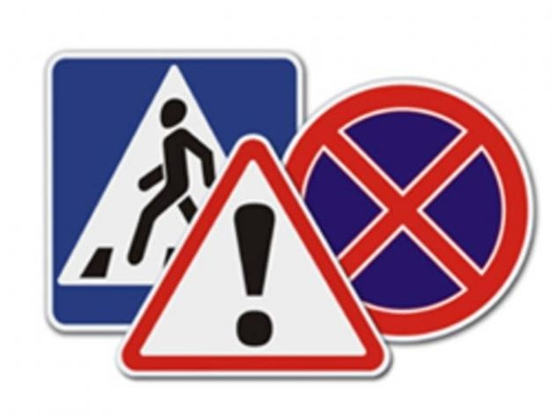
_____________________________________________________________________________
_____________________________________________________________________________
_____________________________________________________________________________

__________________________________________________________________________________________________________________________

__________________________________________________________________________________________________________________________

__________________________________________________________________________________________________________________________

PERMISSIONS

_
_
_____________________________________________________________________________

________________________________________________________________________________

_________________________________________________________________________________
______________________________________________________________________________________________________________

______________________________________________________________________________________________________________

______________________________________________________________________________________________________________
OBLIGATIONS

PROHIBITIONS

PERMISSIONS
Напечатать 3 таких листа на 12 человек

