Викторина по английскому языку дл 5-6 классов «Christmas Quiz»

разработана учителем английского языка Тахтамышевой Ольгой Сергеевной

Hi! This is the quiz for 10-13 years old students. All the participants will get certificates.

A. CHOOSE THE RIGHT VARIANT:
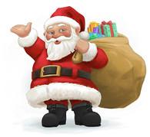
1. Where is Santa from?
a) The UK.
b) The North Pole.
c) The USA.

2. Santa Claus goes into your house through the ….
a) window.
b) chimney.
c) front door.
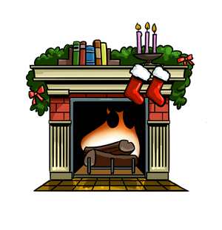
3. What do most elves wear
on the tip of
their shoes?

a) Bells.
b) Holly.
c) Stars.

4. Children hang them by the fireplace on Christmas Eve.
a) bags
b) jeans
c) socks
5. It is an ornament which people usually hang on the front door.
a) ribbon
b) wreath
c) figurine

6. It is the vehicle Santa uses. It is pulled by his reindeer.
a) cart
b) sleigh
c) chariot
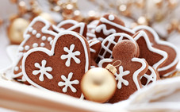
7. A typical sweet that is eaten at Christmas. It comes in different shapes.
a) gingerbread
b) nougat
c) pudding
8. It is a sweet and it usually has red and white stripes.
a) jelly
b) bun
c) candy cane

9. People usually put this ornament on top of the Christmas tree.
a) bell
b) star
c) heart
10. People often use one to tie presents so as to make them nicer.
a) ribbon
b) wire
c) string

B. ANSWER THE QESTIONS:
1. People of which country traditionally give the Christmas tree to Londoners to set it in Trafalgar Square?

2. What Christmas item was invented by Tom Smith in 1847?

3. When is St Stephen's Day celebrated?
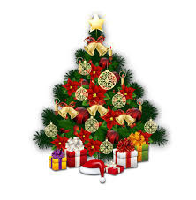
4. In the USA, the day after Thanksgiving is traditionally the start of the Christmas shopping season. How is this day called?

5. What is usually concealed in the Christmas pudding?

6. What do people traditionally do under mistletoe?

7. What is the number of reindeer that Santa has?

C. WHAT IS YOUR FAVOURITE CHRISTMAS TRADITION? WHY?
(Write 5-10 sentences or 25-60 words)

